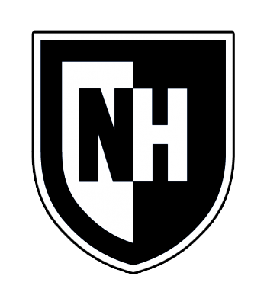
University of New Hampshire at Manchester ASL/English Interpreting - Spring 2025 Syllabus

INTR 539 Comparative Linguistic Analysis for Interpreters
Course/Credits: INTR 539.M1: 3 credits Online: Mondays 1:10pm- 4:00pm, on Zoom Office hours: After class or by appt.
Instructor: Judy Shepard-Kegl, Ph.D.
Email: Judy.ShepardKegl@unh.edu

Course Description
This course examines the basic similarities and differences between the linguistic structure of American Sign Language and spoken English, and focuses on each language’s communication functions and how they serve those functions. Comparison is made between the linguistic features of morphology, phonology, syntax, and semantics, withspecial focus on pragmatics and discourse. (Pre- or Coreq: ASL 532 American Sign Language IV.)

Instructor Title/Rank: Adjunct Faculty
Instructor Department: University of New Hampshire at Manchester

Technical Requirements: You are required to have a scientific calculator or device capable of performing trig functions (sin, cos, tan, etc.) and exponential notation.

Course Objectives
Upon successful completion, students should be able to:
- Describe the mechanisms by which American Sign Language utilizes the visuospatial medium in which it exists to express grammatical relationships;
- Demonstrate understanding of the parts of speech (noun, verb, adjective, adverb, preposition, etc.) and levels of linguistic analysis (phonetics, phonology, morphology, syntax, semantics, and discourse
- Demonstrate recognition that ASL and English are distinct languages with differing grammars; and engage in critical thinking about these differences.
- Identify and discuss at least 8 linguistic areas in which ASL and English differ
- Demonstrate a basic familiarity with the following grammatical constructions in ASL and in English: formational properties, Figure and Ground, Classifiers (object (CL) and handling (HCL)), size and shape specifiers (SASS), determiners (IX) and possessive markers (POSS), verb agreement, direct and indirect address and action, questions, and relative clauses.
The focus of this course is on students becoming aware of the comparative and contrastive features in the grammars of ASL and English and the extent to which awareness of these differences supports efforts to express and comprehend messages in an effort to interpret with a goal of message equivalence. A range of interpreting topics will be addressed as they arise over the semester, but the primary standards adhered to in this specific course content appear below:

Alignment with the Standards of the Collegiate Commission on Interpreter Education:
- 5 The curriculum addresses competencies related to research.
  - The curriculum fosters the continued development of language competency in both ASL and English that prepares graduates to enter the field of interpreting.

  - The curriculum fosters the development of competencies required for meaning
transfer.
  - The curriculum addresses self-assessment of the process and product of interpretation.

Alignment with Student Learning Outcomes based upon Entry-to-Practice Competencies Witter-Merithew, A., & Johnson, L. (2005; p. 143-146). Toward competent practice: Conversations with stakeholders. Alexandria, VA: RID Press.
EPC 1.4 Compare and contrast linguistic characteristics in a variety of signed language interpretations. (R, A)
EPC 1.5 Identify and discuss personal and professional demands that occur during interpreting and identify strategies leading to an effective interpretation. (R, A)
EPC 3.3 Demonstrate advanced and effective public speaking skills in both ASL and English through the spontaneous delivery of an informal and a prepared formal presentation. (I, R, A)

Required Texts (none)
There is no required text, although the following may prove useful to you as optional texts in the class. All required readings will be provided by me electronically on Canvas.

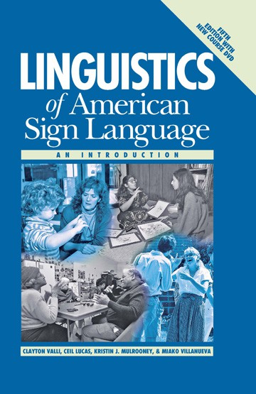
Clayton Valli, Ceil Lucas, Kristin J. Mulrooney, & Miako Villanueva. (2011). Linguistics of American Sign Language: An Introduction (5th Ed.). Washington, DC: Gallaudet University Press. [with new course DVD]

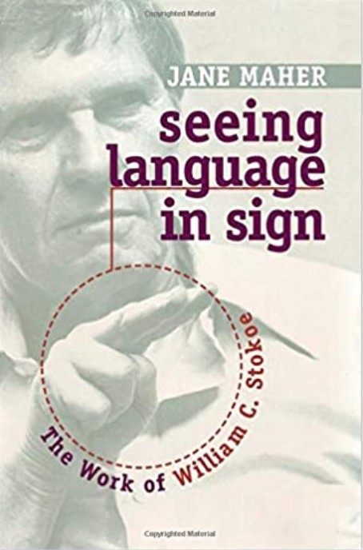
Maher, J. (2010). Seeing language in sign: The Work of William C. Stokoe. Washington, DC: Gallaudet Press. IBN-13: 978-
156368470

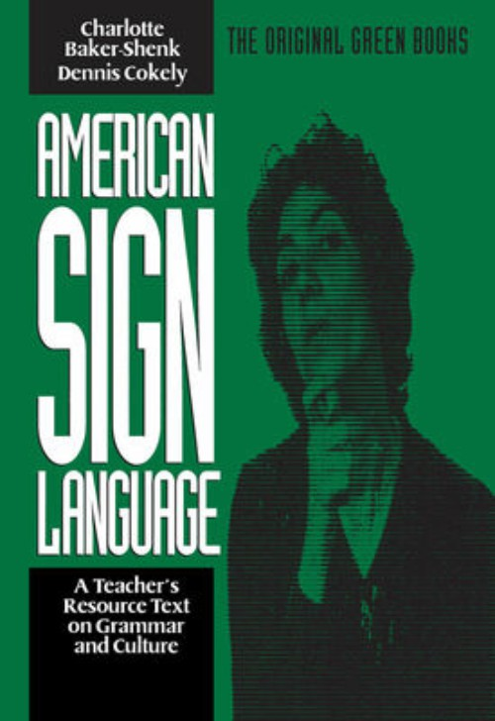
Baker(-Shenk), C. and Cokely, D. (any edition). American Sign Language: A Teacher's Resource Text on Grammar and Culture. Washington, D.C.: Gallaudet University Press.

Assignments. Exams, and points:

Large Projects | Star Spangled Banner Project | 20
Large Projects | Who Am I? | 15
Large Projects | DCCCH (video and  transcription) | 20
In class attendance and participation | This will include assignments  and quizzes done in class | 15
Exams | Midterm | 20
 | Final/Alternative Final Project | 30
Total: |  | 100 points earned  (out of 120 total)

NOTE: Late work will not be accepted. Any extensions must be pre-approved by the instructor, but are unlikely to be given because subsequent classes depend upon finishing the work. No extensions will be given for the deadlines connected to the alternative final project, but any pieces can be handed in early.

94-100 = A  90-93 = A- | 87-92 = B+  84-86 = B  80-83 = B- | 77-73 = C+  74-71 = C  70-73 = C- | 67-72 = D+  64-66 = D  60-63 = D-  59-0 = F
There are 120 points available in the class, but I will grade on the basis of 100 points. The extra 20 points are there to allow me to grade frankly in terms of work submitted. However, if someone doesn't do well on a particular assignment, the buffer of 20 points will not allow one assignment to adversely effect your overall grade.

Attendance, Quizzes, and in-class activities
Your attendance is expected at every class. While I offer regular office hours, I will not re-teach classes that you have missed during office hours, so please arrange to review the Powerpoints, do the readings, and meet with other students to get notes or review with them. I am happy to meet with you about all other aspects of the course and especially about your Alternative Final Project should you choose to take that route.
If a class is missed that involves a in-class quiz or in class assignment, this cannot be made up if you were absent. [15 points]

Three large assignments:
- Star Spangled Banner Assignment: (transcription and labeling of object classifiers, handling classifiers, and SASSs, indicating semantic class and referent for each) [20 points]
- Who Am I? Assignment: Transcription and labeling of 20 ASL sentences, indicating role, person, and number marking of pronouns, role shifts, eye gaze and head tilt [15 points]
- DOG CHASE CAT COME HOME Assignment: Each student will be assigned one sentence in English. They must translate this sentence into ASL with the following restrictions: only the five signs above can be used and used only once; they must occur in the exact order given above; and no additional pointing or signs can be added. The goal is to use non-manual marking, aspectual modulations, and spatial agreement to convey the translation. The assignment

has 2 parts: 1. A full transcription of your ASL sentence with agreement, role shifts, non-manual grammatical markers spread over the appropriate places, etc. and 2. A video of you signing your translation with all the appropriate signs, body shifts, and non-manual markings. [20 points]
Note: In all three assignments, a pre-transcript to get you started will be provided.

Midterm Exam
The midterm exam will cover the course content on Figure/Ground, Classifiers, SASSs, and the internal structure of verbs (classifier clitics and motion/location verbs).

Final Exam/Alternative Final Project [each is worth 30 points]
Final Exam [30]
There will be a final exam that is comprehensive of the course as a whole. It will consist of multiple choice and yes/no questions, as well as some short answers. The final will be in class, hard copy.

Alternative Final Project [30 cumulative, only if completed]
You may choose to do an alternative project in lieu of taking the final. The alternative final project can be on any of the projects listed below, first come first serve. Your project will be in the form of either a pamphlet or stand-alone Powerpoint presentation. In addition, you will do a 5-minute overview of your project (not an exhaustive presentation) for the class. This can be in ASL or English.

To qualify to submit the Alternative Project, you must also meet the deadlines for preparatory work beforehand. If you fail to submit the prep work, then expect to take the final exam. You will not get a grade on your final project before the final, but you will get feedback on your reference, outline, and draft. So, with respect to the final submission, it is one or the other (project or final).
- Project Proposal: A brief description of the topic; Your plan for doing the research (include the process, materials, resources, and people to be interviewed
-- as applicable); Any questions or concerns you want to share.Submission of a central article or chapter (not an internet source) on your chosen topic. [2.5 points, and right to continue]
- Submission of an outline—in outline format (e.g., I, II, III; I.A., I.B.,I,C; I.A.i, etc., not just a summary or list. [2.5 points, and right to continue]
- A rough draft or your pamphlet/Powerpoint using the final format. [5 points, and right to continue]
- Final Submission of the pamphlet/Powerpoint one week before presentation. {10 points, and right to continue]
- Video Presentation; must be submitted prior to the scheduled final exam; you field 2 questions related to your project [10 points]

TOPICS FOR ALTERNATIVE FINAL
  - Fingerspelled loan words in ASL and loan words in English
  - Person marking in ASL and English; what's a dual
  - Contractions in ASL and English

  - Can aspect shift from the hand to the body in ASL?; What does English do that's like this?: They're not vs. they aren't
  - JOHN UPSET MARY—Who's upset in ASL vs. English and why?
  - How does ASL borrow compounds from English? FORTUNE^OF^WHEEL; ROCK^SHEET, etc. (this will require data collection from ASL signers)
  - What's a clitic? In ASL? In English? Do we need a different language for comparison?
  - Why can Deaf people sign with chopsticks? Can you sign if you have few or no fingers? What's the English equivalent?
  - What's a spoonerism? Does ASL have them?
  - Shared space versus signer space
  - How are signs made more visible for platform signing, theater, etc.?
  - What do direct objects do in ASL and English?
  - How can young children fingerspell when they cannot spell yet?
  - Historical change in ASL and in English
  - Encumbered signing—is there an English equivalent?
  - Do DeafBlind signers sign differently than sighted signers? How? Why?
  - Do ASL and English have dialects?
  - Are there signs/words that only one group of ASL signers or English speakers are allowed to use?
  - What's the deal with DON'T^KNOW, DON'T^LIKE, DON'T^WANT, DON'T
    - CARE?; Does English have anything parallel to this?
  - Is ASL sensitive to how our eyes work?
  - What are the symmetry and dominance conditions in ASL and why do they exist?
  - How do numbers work in ASL vs. English?
Note: I am willing to meet with you on Zoom as much as you need to choose, prepare, and revise your alternative final project.

Classroom Learning Approach:
Academic content in linguistics can be challenging. I want to be sure you get all the nuances. Since we are all hearing and, I assume, native users of English, I will be presenting the course material in your native language, English. However, there will be many examples and narratives in ASL, as well as supplementary materials, which will not be interpreted. We can revisit this as the course proceeds should you prefer more lecture in ASL.
Please review the Academic Honesty and the University Code of Conduct in Handbook in Student Rights, Rules and Responsibilities https://www.unh.edu/student-life/student-rights-rules-responsibilities

Plagiarism Tutorial
https://cola.unh.edu/academics/plagiarism-tutorial

Accommodations for Disability
The University is committed to providing students with documented disabilities equal access to all university programs and facilities. If you think you have a disability requiring accommodations, you must register with the Student Accessibility Services (SAS) office. The Student Accessibility Coordinator at UNHM is Jenessa Zurek. Please

reach out to the SAS office via email at jenessa.zurek@unh.edu for registration information and disability related questions.

Students of all Faiths
In the event that a student needs accommodation for a religious or cultural holiday/observance, that student is encouraged to inform your instructor as early in the semester as possible.

Class Recording
Students’ enrollment in a UNH course is consented to being recorded by UNH media platforms for educational and remote access purposes. The University and Zoom have FERPA-compliant agreements in place to protect the security and privacy of UNH Zoom accounts. Students may not share recordings outside of their course.

UNH-M Library
The UNH Manchester librarians are available to assist you with your research. You may contact a librarian through phone, 603-641-4173 or email, unhm.library@unh.edu.
The following online resources provide information about library resources and services:
UNH Manchester Library webpage: https://manchester.unh.edu/library Online Research Guides: https://libraryguides.unh.edu/index.php?b=s
Access Library Resources Remotely: https://libraryguides.unh.edu/remoteaccess Reserve a study room for Zoom classes: https://libraryguides.unh.edu/remoteaccess/studyrooms
If you have not previously used the resources of a librarian for your research, I strongly recommend taking this opportunity to do so. Knowing how to look and where to look will simplify your academic life overall.

Academic Alerts
The University is invested in your academic success. If a faculty member is concerned about your academic behavior or performance, they may submit an academic alert.
Academic alerts are not punitive. The goal is to provide you with support and resources to support your success. They act as an important check-in point and, if you receive an academic alert, you will receive an email to your UNH email address. It is strongly recommended that you meet with a professional advisor and connect with your instructor to discuss the reason for the alert.

Center for Academic Enrichment
Provides academic support services, including individual tutoring, for all students. Make an appointment through the CAE My Courses site on your Canvas dashboard. Phone: (603) 641-4113. Email: unhm.cae@unh.edu
I strongly recommend using the resources of the writing center for your Alternative Final Project should you choose to do one. Check in at the outline and draft stages.

Food Pantry
The campus food pantry has pre-packed bags of non-perishable food items for students in room 437. If you have any questions, contact Lisa.Enright@unh.edu.

Mental Health and Wellness

In partnership with The Mental Health Center of Greater Manchester, UNH Manchester offers free mental health sessions for students. Students can schedule virtual counseling sessions by emailing unhm.advising@unh.edu. Counselors will be available virtually on Monday, Tuesday, and Thursday from 9am-5pm.

The National Suicide Prevention Lifeline
provides 24/7, free and confidential support via phone or chat for people in distress, resources for you or your loved ones, and best practices for professionals. Call (800) 273-TALK (8255).

Confidentiality and Mandatory Reporting
The University of New Hampshire and its faculty are committed to assuring a safe and productive educational environment for all students and for the university as a whole. To this end, the university requires faculty members to report to the university’s Title IX Coordinator (Donna Marie Sorrentino, dms@unh.edu, 603-862-2930) any incidents of sexual violence and harassment shared by students. If you wish to speak to a confidential support service provider who does not have this reporting responsibility because their discussions with clients are subject to legal privilege, you can find a list of resources here ((privileged confidential service providers/resources).
For more information about what happens when you report, how the university considers your requests for confidentiality once a report is made to the Title IX Coordinator, your rights and report options at UNH (including anonymous report options) please visit (student reporting options).

Sexual Harassment and Rape Prevention Program (SHARPP)
Provides free and confidential advocacy and direct services to survivors. https:/www.unh.edu/sharpp.)

COVID-specific Policies and Guidance
Check this website for the latest information: https://manchester.unh.edu/coronavirus-covid-19-updates

Course Schedule
Each week will appear as a module on Canvas. A schedule is included at the end of the syllabus as well.

 | Course Schedule | All assignments or project submissions  are due by noon | Alternative Final Project
1/27 | Introduction to class; ASL ≠  English
2/3 | Figure and Ground; SSB Project  Handed out
2/10 | Object Classifiers (CLs)
2/17 | Handling Classifiers (HCLs)
2/24 | Size and Shape Specifiers (SASSs) |  | Proposal due; with  reference
3/3 | What’s the point? What does the index finger do in ASL? Who Am I  project handed out. | SSB Project Due
3/10 | MIDTERM on ASL ≠English; Figure/Ground; CL, HCL, SASS;  structure of verb | MIDTERM
Break
3/25 | Direct and Indirect address;  direct action |  | Outline due
3/31 | Aspectual Marking, DOG CHASE CAT COME HOME (DCCCH)  problem handed out | Who am I? due
4/7 | Relative Clauses
4/14 | Questions |  | Draft due
4/21 | Topics and Conditionals
4/28 | ASL Sucks: Applicative  Constructions |  | Final pamphlet or PP  due
5/5 | Bringing it all together; Presentations of Alternative Final  Projects | DCCCH due (transcript and  video) | presentation
FINAL |  | FINAL | If you submitted and presented and alternative final project, you are excused from  the final.

